Documentation of Employer

1. **Employer Sign-Up:**

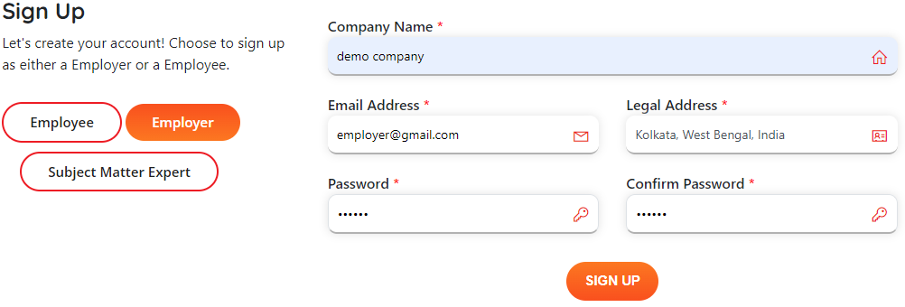

1. **Email Notification:**

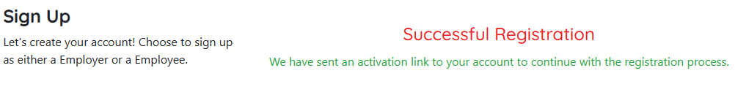

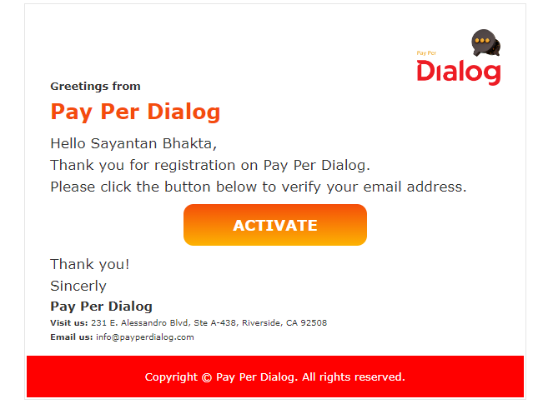

User can only login after clicking on the **“Activate”** button.

1. **Login as an Employer:**

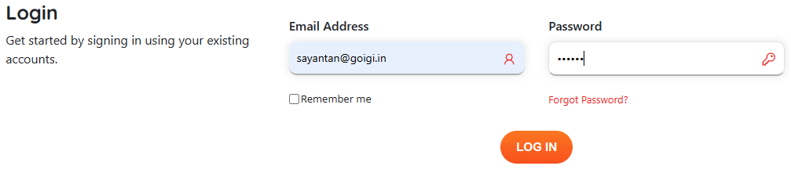

1. Employer need to fill the required fields before accessing the other tab. Employee can post job.

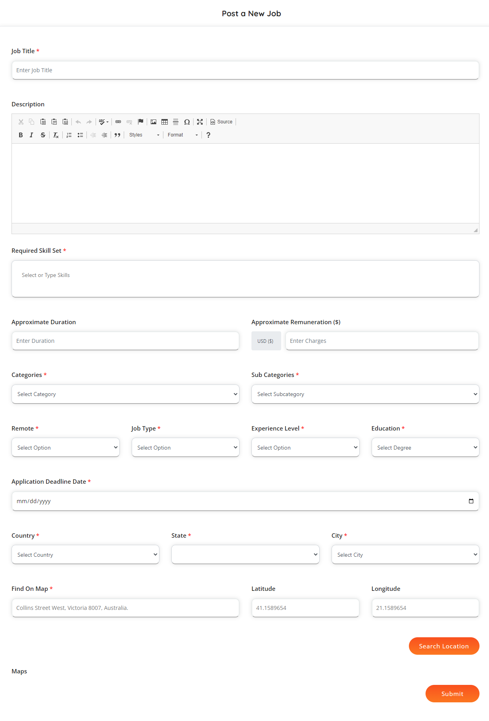

1. **My Jobs for employer:**

In my jobs “Post jobs” button will be there, if there is no job post by employer.

Click on the “Apply for jobs”, employee will be redirecting to the New post job page. (Screenshot Above)

Once job add in will show in the frontend job listing page and also in the employer “My Job” tab.

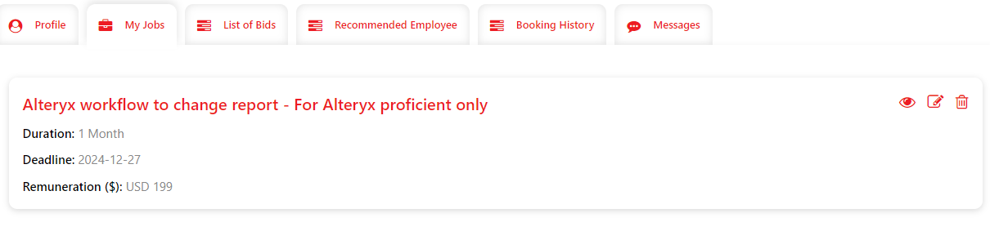

1. **List of Bid:**

If any employee bid any job from the job listing page the bided job for that particular employer will show in the “List of Bid” page.

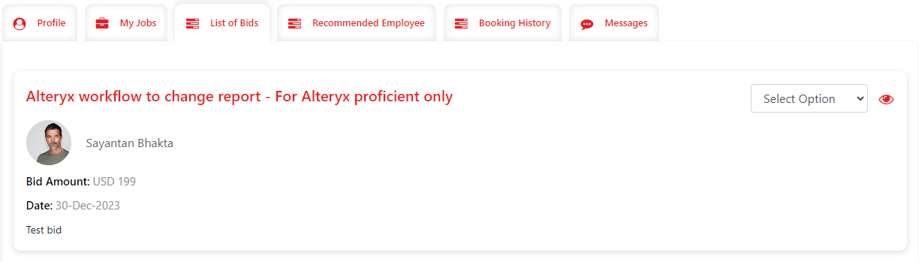

By default if will show as select option. Employer can change the status of the post. Once the status became “Selected” that particular employer and employee cam communicate through “Message” tab.

1. **Recommended Employee:**

Based on the job title employer can search employee from “Recommended Employee” tab.

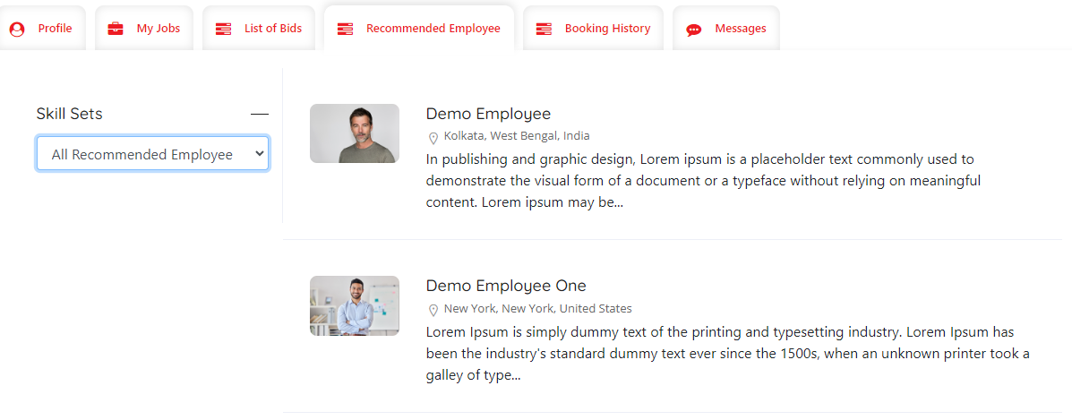

1. **Booking History:**

Once any employer books any slot from employee details page, the booking data will show in this tab.

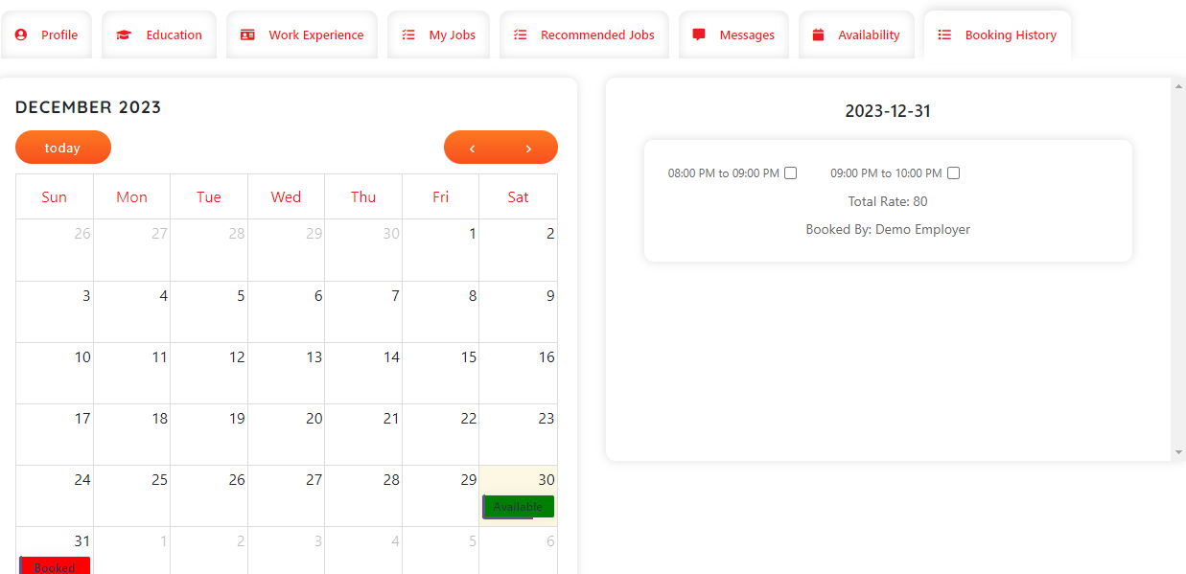

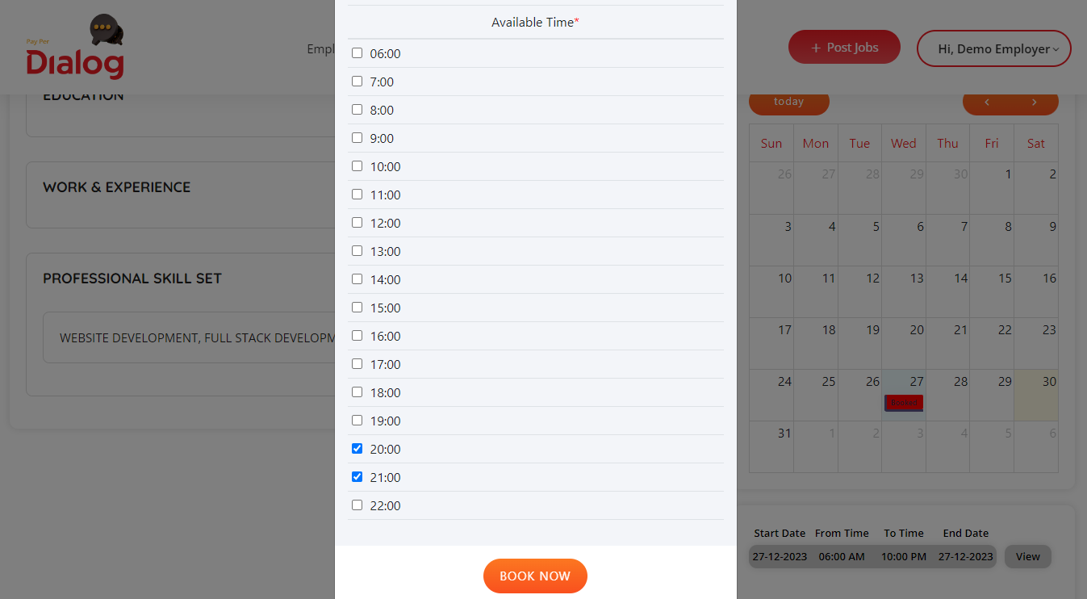

After click on the book now button employer will get “User’s Agreement” popup.

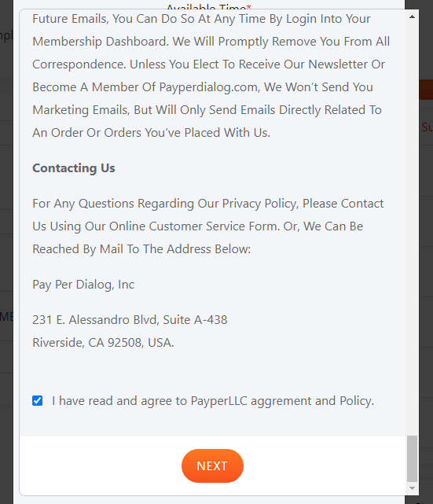

After check the checkbox and click on the “Next” button employer will see the booking details with rate (employee can add rate in profile tab).

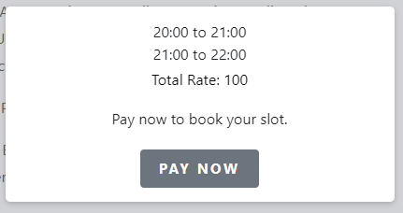

Once click on the “Pay Now” button employer can successfully book the slot for that particular employee. This booking details will show in “Booking History” tab for both employee and employer profile.